Prefix: sub Meaning: under, below

subconscious: adjective. Not fully aware; occurring below your level of thinking and awareness

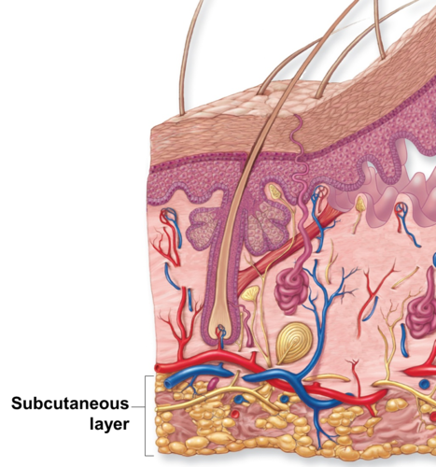
subcutaneous: adjective. Under the skin

subdue: verb. To bring under control

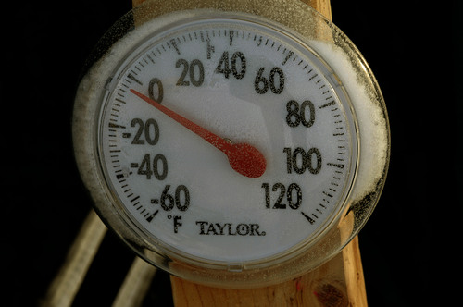
subfreezing:
adjective. Below the freezing point

subirrigate: verb. To water something from under the ground

subject: verb. To put under someone else’s control

submarine: noun. A watercraft that stays under water

submerge: verb. To put under water

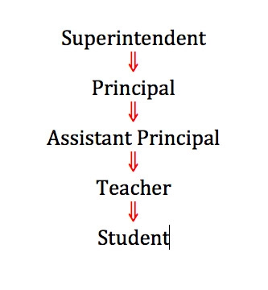
subordinate: noun. A person who is under someone else in rank or importance

subway: noun. A passageway under the ground; an electric underground railway

